Survey on the implementation of compulsory education in rural areas

**________________________________________**

**A Research Proposal Submitted to**

**Dr. Arthur S. Abulencia, Faculty of Graduate School**

**Jose Rizal University**

**Mandaluyong City**

**________________________________________**

**In Partial Fulfillment of the Requirements for**

**GS 222 Research Methods**

**________________________________________**

by

**Avine**

**September 2020**

**Abstract**

**Background:**

Compulsory education is the school education of certain degree that the country USES legal form to stipulate to implement free to certain age child namely. Talent and educational resources were scarce: at that time, less than 20 per cent of primary school-age children were enrolled, only 6 per cent of secondary school children were enrolled and more than 80 per cent of the population was illiterate. Since the reform and opening up, Under the conditions of a large population and a low level of productivity, China has achieved the historic task of "two foundations" (basically popularizing nine-year compulsory education and basically eliminating illiteracy among young and middle-aged people) and achieved remarkable achievements. So I did a survey of our town

**Keyword :** Countryside, compulsory education, family, school, government

**Methods:**

Due to the epidemic situation and the limitation of being abroad, this survey adopted three methods: questionnaire survey, individual interview method and data collection method. The questionnaire was released to WeChat group through WeChat platform. Finally, I collected some information about the school from the principal of the primary school.

**Method or Procedure**

(1) Clarify the question of investigation;

(2) Determine the object of the investigation;

(3) Choose the method of investigation;

(4) Launch an investigation;

(5) Record the results;

(6) Draw conclusions.

**Instruments**

A4 paper

computer

**Results:**

Recall 106 valid questionnaires. Among the respondents, those under 25 years old account for 10.63%, those between 26 and 45 years old account for 50%, those between 46 and 65 years old account for 29.78% and those over 65 years old account for 9.57%.) I also conducted targeted interviews with individual parents and students.

**Statement of the Problem**

1. Parents' emphasis on family education.  
2. Correlation between education level and family income.  
3. Parents' support for their children's education.  
4. How well parents understand today's educational policies.  
5. What parents are most concerned about is education.  
6. Parents' comments and expectations on the work of the local government in education

**Conclusions:**

Through this survey, we can find a nine-year compulsory education fee system and two free nine-year compulsory education students (textbooks and tuition and fees) one filling (born poor accommodation for living allowance) policy implementation, has greatly promoted the development of the rural basic education, however, the reform of basic education and effective implementation needs to be a long way to go, the present situation of the weak rural basic education is still not completely changed.  
Revitalization of the rural basic education, the middle should encourage push through increased investment in state of funds, advanced education resources support, strengthening the government functions of education, strengthen the management of school peripheral environment and social environment, and a series of measures to speed up the pace of rural basic education, at the same time also need to quicken the development of rural economy, increasing farmers' income. Only with the development of rural economy, can the ability of farmers to send their children to receive education be greatly improved, and the phenomenon of avoiding dropping out of school and going out to work can become a reality. Rural basic education and rural economic development complement each other. As long as from these two aspects simultaneously diligently, believed that our country countryside elementary education appearance will produce the essential change.

**Significance of the Study**

The results of the study will be significant for the following:

The family.

Family can understand that the country's resources to allocate a large number of children's compulsory education, as parents should defend their children to enjoy the right to compulsory education. Strengthen individual parents' sense of responsibility for compulsory education.

The student.

For students to understand their own country's compulsory education brother development and current situation, can deepen the understanding of compulsory education; Moreover, the education reform is closely related to themselves, so that students know that the education they currently enjoy which they take for granted is hard-won. It is also an obligation to guide them to treat their right to education correctly.

The teachers.

For teachers, they can review the reform history of modern pedagogy, have a comprehensive understanding of the great educational reform route of the motherland, and make clear their position: guide students with goals in their own educational career.

The school leaders.

For school leaders: School leaders are important planners and implementers in the popularization, development and reform of compulsory education, and play a pivotal role in connecting the preceding and the following. Responsible for the national policy indicators, responsible for the quality of education. We should bear in mind the national compulsory education popularization policy and guide teachers to implement the compulsory education plan according to the actual situation; And guide teachers to accumulate and sum up the experience of education, diligent themselves to make contributions to the development of compulsory education.

**Review of Related Literature**

**-- The popularization and development of compulsory education since the reform and opening up 40 years ago**

1. Restoration and Preliminary Development of Universal Education (1977-1985)  
   After the end of the "Cultural Revolution", universal primary education was officially put on the agenda along with the efforts to put things right. The Ministry of Education issued instructions on the popularization of primary education in rural areas for five years.
2. Comprehensive Promotion of universal Compulsory Education (1986-2000)  
   1. Full implementation of Compulsory Education (1986-1992)  
   In April 1986, the Compulsory Education Law of the People's Republic of China was promulgated. The law provides in principle some important issues such as the nature, duration and guarantee of compulsory education, which indicates that the popularization and development of compulsory education in China has entered a new stage of legalization.  
   2. Continuous Promotion of Compulsory Education (1993-2000)  
   In February 1993, the State Council issued the Outline for China's Educational Reform and Development, which clearly set the goal of making nine-year compulsory education basically universal and basically eliminating illiteracy among young and middle-aged adults by the end of the 20th century. In March of the same year, the National People's Congress passed the Education Law of the People's Republic of China, which formed the legal system of compulsory education in China.
3. The Rapid development of Compulsory Education since the new century (2001-)  
   1. We will promote the strategic plan for popularizing compulsory education in poor rural areas  
   In order to accelerate the popularization and development of compulsory education in rural areas and the poor areas in the central and western regions, and to develop compulsory education in urban and rural areas in a balanced way, the State Council invested 5 billion yuan from the central government to implement the second phase of the National Compulsory Education Project for Poor Areas.  
   2. We will improve the management system for compulsory education in rural areas  
   In 1994 caused by "system" after the reform of rural compulsory education funding shortage, in May 2001, the State Council issued a "decision on reform and development of basic education, emphasis on rural compulsory education" under the leadership of the State Council, shall be the responsibility of the local government, system of classification management, mainly on county ", the compulsory education of the school responsibility and administrative privileges on the county level, the compulsory education also changes from farmers for the main responsibility of the government.  
   3. Revise and promulgate the new Compulsory Education Law  
   At the end of 2003, the Ministry of Education launched the revision of the Compulsory Education Law. Over the past three years, we have made it clear that compulsory education is fully covered by the financial guarantee system, written into the legal system the management system of compulsory education, and increased the implementation of quality-oriented education in compulsory education to the legal level.  
   4. We will increase government funding for and investment in compulsory education, and make it free of charge across the board  
   Service education is to realize the popularization of compulsory education with high quality. In the past ten years, our country has been strengthening the improvement and construction of the mechanism in the fund guarantee of compulsory education.

Total input of national education

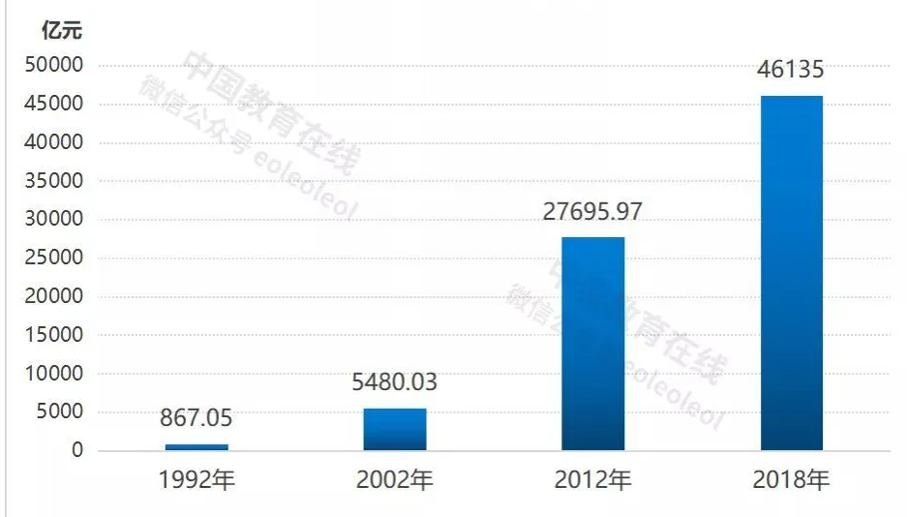

Source: Ministry of Education website

**-----Achievements were made in popularizing and reforming basic education across the country**

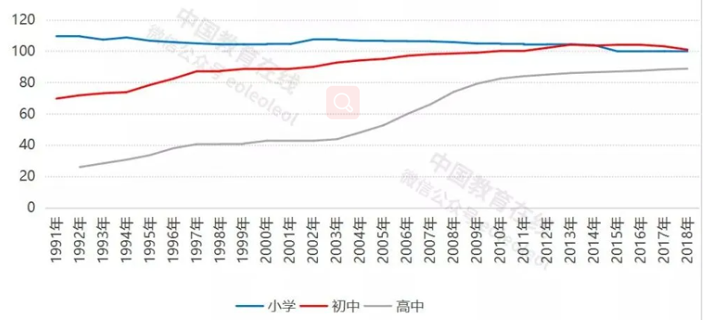

Compulsory education and high school gross enrollment rate

1.In April 2017, the State Council authorized the publication of the Plan for Achieving Universal Access to High School Education (2017-2020). According to the plan, high school education will be universal nationwide by 2020, and the gross enrollment rate of all provinces (autonomous regions and municipalities directly under the Central Government) should reach more than 90 percent.

1. Pay attention to the construction of rural teachers, improve the treatment of teachers  
   Countries since 2006 the implementation of rural compulsory education stage school teacher AD hoc jobs plan, through public recruiting college graduates to "two basics" in western counties under the county rural compulsory education school, guide and encourage college graduates to work in the rural education, step by step to solve such problems as insufficient total amount and the unreasonable structure of rural teachers, improve the overall quality of the contingent of rural teachers.

Comparison of the number of teachers at all levels in 1949 and 2018

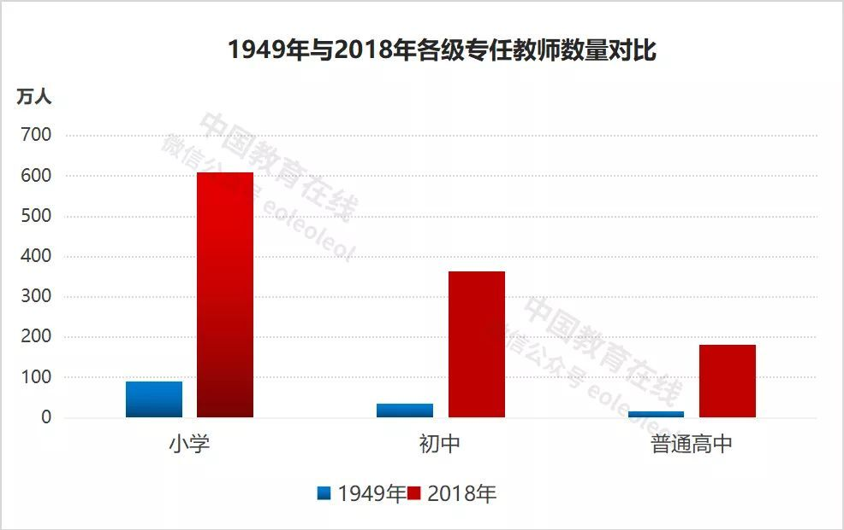

With the rapid expansion of enrollment and enrollment of students at all levels, the number of full-time teachers at all levels of education also grows rapidly. Among them, the number of full-time primary school teachers increased from 836,000 to 6,091,900, an increase of 7.3 times. The number of full-time teachers in junior middle schools increased from 52,600 to 3.639 million, an increase of 69.2 times. The number of full-time teachers in regular high schools increased from 14,000 to 1,812,600, an increase of 129.5 times.

**Conceptual Framework**

1. **Questionnaire**

**(1) The concept of family education**

1. Parents' emphasis on family education.  
Among the respondents, 42.22% attached great importance to family education, and 21.11% attached great importance to it. This shows that parents have realized the importance of family education in the three-dimensional education system of society, school and family, and it is a kind of progress of parents' concept.

2. Correlation between education level and family income.  
When asked whether education level has an impact on household income, 47.19% think it has a significant impact and 39.33% think it has a certain impact. Through analysis, we can see that parents generally believe that education level has a greater impact on future family income, but the "theory of useless reading" and "theory of poverty caused by reading" also exist to a certain extent, which may be affected by the difficult employment of college students in recent years. Therefore, government departments should pay attention to the employment problem of college students and solve this problem. On the one hand, government departments should examine the situation in a general direction and reform and innovate the education system with great determination. On the other hand, colleges and universities should also pay attention to training a group of college students with high theoretical literacy and strong practical operation ability. Only in this way can college students better adapt themselves to the needs of future jobs.As for the phenomenon that rural students go to work instead of going to school, 44.83% think they should not, because studying is the way out for them, while 26.44% think it is difficult to say, and it is difficult for them to choose between developing first and surviving first. This shows that most parents are opposed to their children not going to school and going to work. However, due to the difficulties in real life, some parents only take into account the immediate interests while ignoring the long-term benefits brought by their children's education.

1. Parents' support for their children's education.  
   In the case that the children have excellent academic performance but the family cannot afford to send them to school, 72.83% of the children will borrow money to go to school, 20.65% will sell their property to send them to school, and only 6.52% will let them drop out of school. These data all reflect the parents hope their children to be successful and their daughters to be successful, and highly support their children to receive education psychology.  
   4. How well parents understand today's educational policies.  
   In recent years, the state attaches great importance to the issue of compulsory education, has issued a number of education policies, but only  
   1.25% are very familiar with the current national policies on rural compulsory education, 15% are relatively familiar with them, 27.5% have some knowledge, and up to 56.25% are not very familiar with them, which reflects that the local government's publicity efforts on education policies are not enough, and the publicity coverage is limited.  
   5. What parents are most concerned about is education.  
   50% of parents are most concerned about the teachers, 21.88% are most concerned about the education system reform, 14.58% are most concerned about the teaching environment of the school, but still 13.54% are most concerned about the tuition issue. The trend of diversification of educational programs is the most concerned by parents, which indicates that parents' educational concepts have been improved, while the proportion of tuition fees they are most concerned about is not high. This reflects from one side the development of rural economy, the improvement of people's living standards, and the issue of food and clothing is no longer the primary consideration.
2. **Parents' comments on the work of the local government in education.**
3. Evaluation of local government action on education.  
   44.44% think that the government's action performance is average, even 26.67% think that the government does not pay enough attention to education, education is related to the future development of the country, local government should pay more attention to education, so as to change the backwardness of rural areas.  
   Parents' expectations of local education.  
   When talking about "the main focus of improving current rural education", parents are full of expectations for local education.  
   20.44% thought to improve teacher education teaching level main focus is to improve the current rural compulsory education, 18.23% thought that strengthen the management of school peripheral environment and social environment, 11.05% believed to strengthen government functions of education, to improve the situation of rural education is the main focus, 9.94% think parents knowledge and consciousness to improve education, increase 9.39% think that is a country of rural compulsory education of planning and investment, strengthen rural nine-year supporting the construction and management, construct school 7.61% think is to enhance the applicability of the rural teaching materials, teaching material of writing is closely linked with employment, 7.18% think it is reasonable to adjust the distribution of education and vigorously develop vocational education oriented to rural areas; 6.08% think it is to strengthen the construction of new rural areas, effectively reduce the burden of farmers and enhance farmers' educational awareness; 11.08% think it is the other.
4. **Video interview**

Interview Wen Zuyi who is the principal of Hope Primary School in Hepu County, Guangxi in China, and give the following points：

1. Adhere to the exam-free nearby enrollment system. The enrollment of schools in the stage of compulsory education in our school shall, in accordance with the principle of nearby and exam-free enrollment, ensure 100% coverage of the region and ensure that every school-age child and teenager in the stage of compulsory education is exam-free enrollment. This year, 111 students enrolled in junior middle school and 138 students enrolled in first grade. The primary school enrollment rate is 99.88% and the junior middle school enrollment rate is 89.29%.  
2. Pay attention to the enrollment of students from disadvantaged groups, do a good job in the work of "two exemptions and one subsidy", care about retention, increase the financial aid to poor students, so that poor students can get in, can afford to read, and can stay. Mr. Zhao Qicheng, a private entrepreneur of Datong, donated school uniforms worth more than 70,000 yuan to 962 students...  
3. Strengthen the management of student status. The Education and Guidance Office shall establish and improve student status management files, be responsible for the management of student status, establish and improve students' files as required, and keep them properly. Students' status information shall not be filled in, changed or disclosed without authorization.  
4, the school full implementation of quality education, seriously implement the provincial, city and county education work conference spirit, in line with, for parents, for education, for students to take responsibility for their attitude, strict enforcement of national and local curriculum plan and schedule, unified regulate the behavior of running a school, according to the project of middle and primary school opened his course category, full class, not casually courses and classes. Local courses shall be offered in accordance with the provincial compulsory education curriculum and school curriculum guidance and implementation guidelines, and the class hours shall be guaranteed and included in the school curriculum schedule.  
5. Strictly implement the "Ten Prohibitions on Compulsory Education In Running Schools", regulate teachers' behaviors, and earnestly strengthen teachers' management. We will conscientiously implement the Opinions of the Ministry of Education on Further Strengthening and Improving the Construction of teachers' Ethics, strengthen the education and assessment of teachers' ethics, and guide the majority of teachers to love their students and teach. We will resolutely put a stop to paid tutoring by a small number of teachers

**The Pro found in the questionnaire and suggested measures**

1. Teachers have a weak sense of responsibility.  
   In the process of talking with parents, I found that parents generally reported that some teachers from the county came to school late and left work early every day. In addition, some teachers do not often correct homework, and rarely go to the countryside to visit students' parents' homes, to reflect some of the students' situation in the school to parents, teachers and parents communication is very rare.  
   For this kind of situation, on the one hand, education departments and schools should improve teachers' teaching situation of evaluation system, title through system, assessment level hierarchy system, commend outstanding teacher in charge, criticism education examination unqualified teachers, parents and students is not happy, for the education is still not correct, be dismissed or reduce the title.  
   On the other hand, we can establish a social supervision and assessment system to make school leaders outside the social personage  
   Can also participate in the assessment of teachers.

2. The aging trend of teachers is serious. The education level of primary school teachers is generally not high, and few teachers graduated from undergraduate colleges.  
To solve this problem, the government departments can increase the investment in rural education, strengthen the construction of rural educational resources, and improve the conditions for running schools in rural areas. At the same time, a series of preferential policies can be formulated to attract university students, especially those from normal colleges and universities, to teach in rural areas. The participation of college students can not only bring some advanced educational concepts and models, but also help to cultivate students' innovative thinking, realize all-round development, and meet the needs of educational reform and development under the new implementation.

3. There are few teachers who understand information technology, few modern multimedia devices are used, and serious waste of educational resources. This problem can also refer to the above solutions to strengthen the communication and cooperation between rural and urban teachers.  
In addition, government departments can increase the assistance of science, technology, culture and medicine in colleges and universities to bring benefits to more backward areas.  
Finally, local teachers regularly go to nearby towns to receive training and further education to increase their confidence in technical aspects

**References**

* <https://gdae.gdedu.gov.cn/gdjyyjy/byyjcg/202008/f705b3813de547fab23e4880648019dd.shtml>
* <https://new.qq.com/omn/20191003/20191003A03JOW00.html>
* <http://www.moe.gov.cn/jyb_xwfb/s5147/201909/t20190926_401046.html>
* <https://www.theworldcouncil.net/uploads/8/6/2/1/86214440/wang_gce_vol._1_no._1_chinese.pdf>
* <http://www.hprc.org.cn/gsyj/whs/jys/201702/P020170223548371463677.pdf>
* <http://www.shxyj.org/Admin/UploadFile/20130926008/2015-09-07/Issue/tye11fkn.pdf>
* <http://www.gov.cn/jrzg/2010-07/29/content_1667143.htm>

-<http://www.fanwen118.com/info_21/fw_3408450.html>

-<http://www.fanwen118.com/info_22/fw_3499564.html>

-<http://www.fanwen118.com/info_21/fw_3469228.html>